Nusaibar
Humanitarian Crisis in Mexico and Central America
The United States administration is a discussion of the issue concerning the humanitarian crisis along the border with Mexico, and the U.S. has the thought of constructing a border wall. As a humane medical association treating persons in Salvador, Honduras, and along the relocation route through Mexico. According to 2017, information on the dangers Central Americans face along the immigration paths shows the critical unmet medical and humanitarian requirements people have, and the threats they face while in Mexico (Cone and Bonacasa 2017).
In a surprising twist, the secretary of motherland security, vice president, and the president have newly detained on data from 2017 report by Doctors Without Borders that disclose dangerous violence agonized by our patients in their home nations and along the migration path, to make a case for hard border implementation. Administration executives are vital in selecting our data to validate regulations that would set-up susceptible persons in regions where their lives are at threat, and they are disregarding our references about how to discourse the genuine medical requirements of immigrants and asylum-seekers.
By emphasizing the risk facing immigrants, the Organization is putting efforts to make the case that a boundary wall could decrease the fears and strengthen the United States' national safety. They are, at the moment, mischaracterizing and misrepresenting the data from our information to push for procedures that run counter to all we believe in. The immigrants leaving Mexico for the United States who receive treatment in the border reported that the perpetrators of violence included members of gangs and other criminal organizations as well as the Mexican safety forces who are mandated to give protection to its citizens (Castillo 2016).

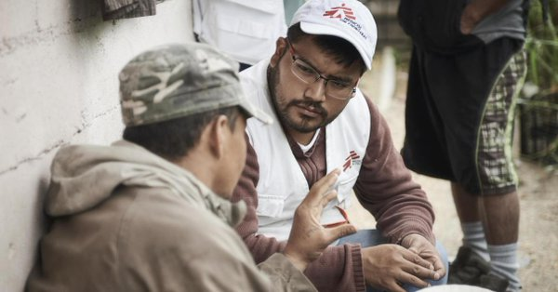

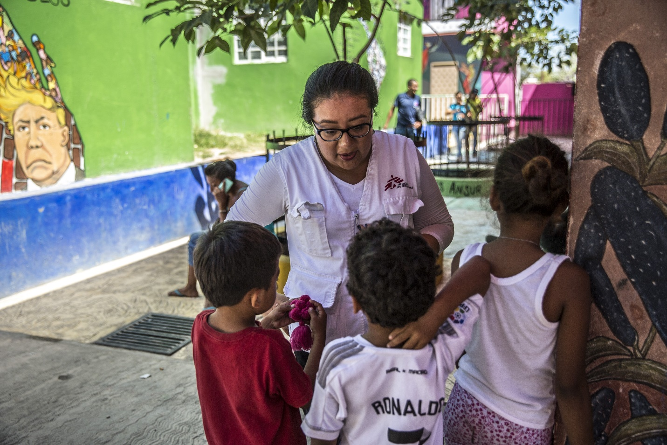
An image of immigrants receiving treatment on the border of America and Mexico.

References
Castillo, A. (2016). The Mexican Government’s Frontera Sur Program: An Inconsistent Immigration Policy. Washington, DC: Council on Hemispheric Affairs. http://www. coh a. org/wp-content/uploads/2016/10/The-Mexican-Government% E2, 80.
Cone, J., & Bonacasa, M. B. (2017). Invisible War: Central America's Forgotten Humanitarian Crisis. Brown J. World Aff., 24, 225.
Musalo, K., & Lee, E. (2017). Seeking a rational approach to a regional refugee crisis: lessons from the summer 2014 “surge” of Central American women and children at the US-Mexico border. Journal on Migration and Human Security, 5(1), 137-179.

